DATABASE MANAGEMENT SYSTEM

COLLEGE CLUB MANAGEMENT SYSTEM

MINIPROJECT

SECTION: F

NAME (1): MK VISHWAAS

SRN (1): PES1UG22CS312

NAME (2): MOHUL YP

SRN (2): PES1UG22CS360

1. Description about the statement (Short abstract)

We aim to simplify the management of college clubs by providing a platform that makes it easy for students to create, join, and participate in club activities, while also empowering club leaders to effectively manage their organizations.

1. ER Diagram

1. Relational Schema

1. DDL Commands

We have use different types of ddl commands :

CREATE DATABASE:

CREATE DATABASE ClubManagement;

CREATE TABLE:

Ex: CREATE TABLE Users ( user_id INT PRIMARY KEY AUTO_INCREMENT, username VARCHAR(50) UNIQUE NOT NULL, password VARCHAR(255) NOT NULL, role ENUM('admin', 'faculty', 'member') NOT NULL );

FOREIGN KEY Constraints:

Ex: FOREIGN KEY (club_id) REFERENCES Clubs(club_id)

TRIGGER:

Ex: CREATE TRIGGER before_sponsor_insert

BEFORE INSERT ON Sponsors

FOR EACH ROW

BEGIN

IF NEW.amount < 100 THEN

SIGNAL SQLSTATE '45000' SET MESSAGE_TEXT = 'Sponsor amount must be at least Rs.100';

END IF;

END;

1. CRUD operation Screenshots

Create:

Before create:

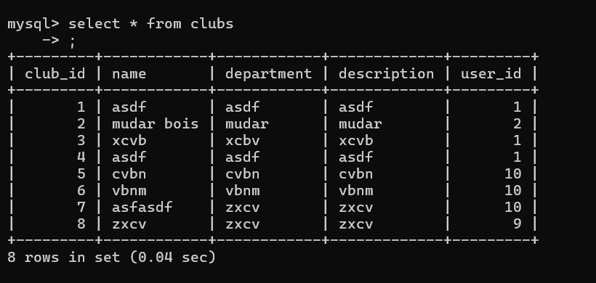

After create:

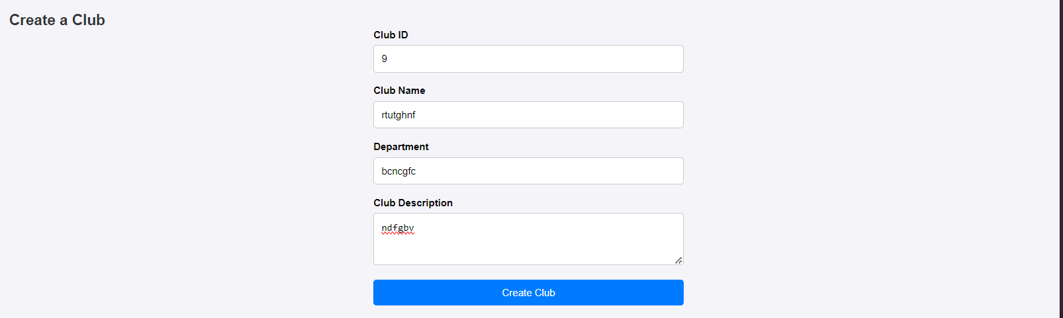

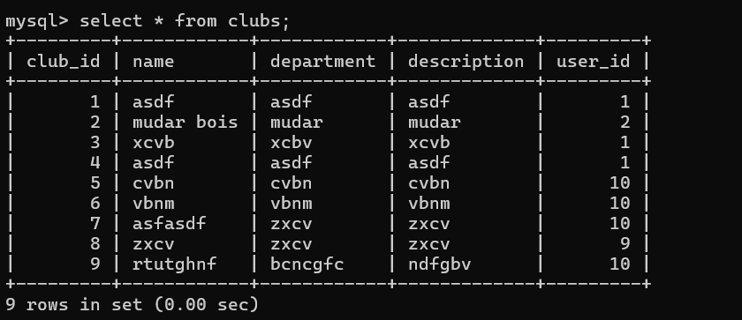

SQL Query :  "INSERT INTO Clubs (club_id, name, department, description, user_id) VALUES (%s, %s, %s, %s, %s)",

                    (club_id, name, department, description, user_id)

Read:

SQL query : DELIMITER //

CREATE PROCEDURE GetEventsByClub(IN clubID INT)

BEGIN

    SELECT * FROM Events WHERE club_id = clubID;

END //

DELIMITER ;

Update:

Before update:

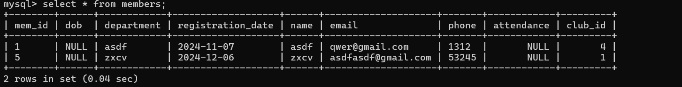

After update:

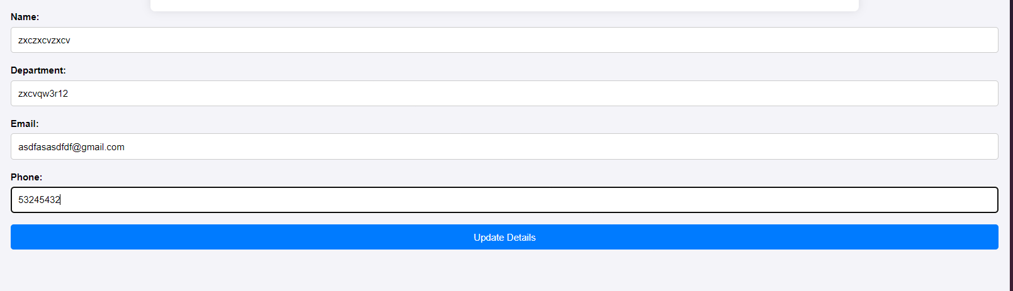

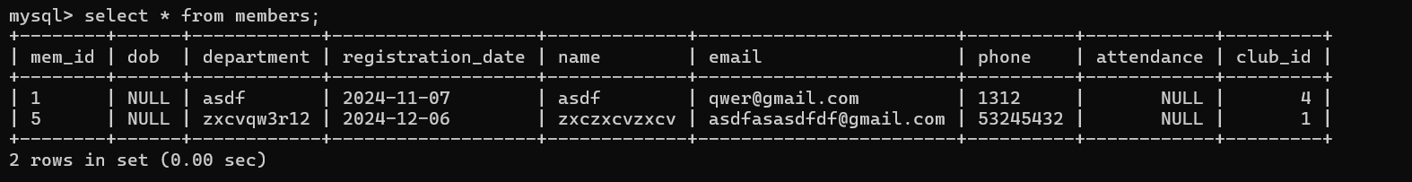

SQL Query :

UPDATE Members

SET

department = %s,

registration_date = %s,

name = %s,

email = %s,

phone = %s,

club_id = %s

WHERE mem_id = %s;

Delete:

Before delete :

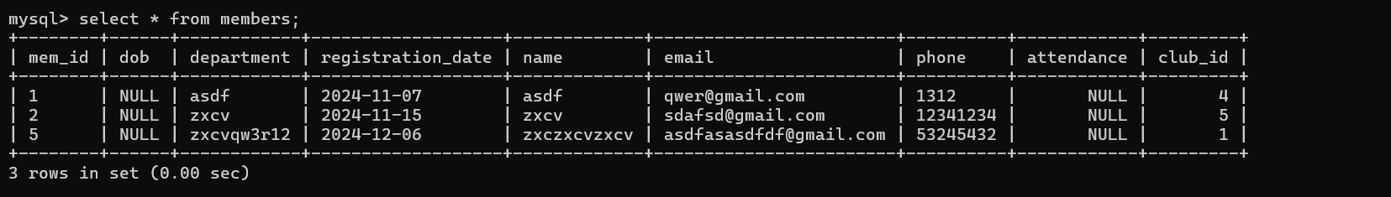  
After delete:

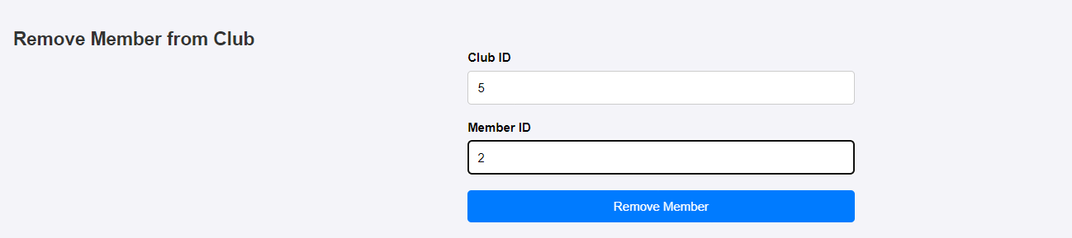

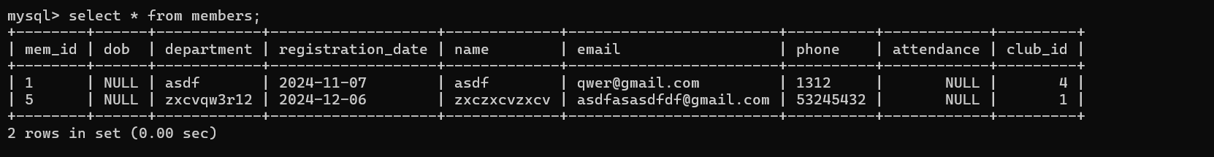

SQL query : DELETE FROM Members WHERE mem_id = %s AND club_id = %s", (member_id, club_id)

1. List of functionalities/features of the application and its associated screenshots using front end:

signup:

Login:

Club admin:

Member module:

Faculty module:

1. Triggers, Procedures/Functions, Nested query, Join, Aggregate queries

Trigger to ensure sponsor amounts are at least Rs. 100.

Procedure to get all events for a specific club.

Nested query to get all member details of the club a faculty member belongs to.

Join and aggregate queries to find the total sponsorship amount for each club.

1. Code snippets for invoking the Procedures/Functions/Trigger

Procedure 1:

DELIMITER //

CREATE PROCEDURE GetEventsByClub(IN clubID INT)

BEGIN

SELECT * FROM Events WHERE club_id = clubID;

END //

DELIMITER ;

Procedure 2: DELIMITER //

CREATE PROCEDURE GetAllClubs()

BEGIN

SELECT * FROM Clubs;

END //

DELIMITER ;

Trigger:

DELIMITER //

CREATE TRIGGER before_sponsor_insert

BEFORE INSERT ON Sponsors

FOR EACH ROW

BEGIN

IF NEW.amount < 100 THEN

SIGNAL SQLSTATE '45000' SET MESSAGE_TEXT = 'Sponsor amount must be at least Rs.100';

END IF;

END //

DELIMITER ;

Join and aggregate query:

SELECT Clubs.name AS club_name, SUM(Sponsors.amount) AS total_sponsorship

FROM Sponsors

JOIN Clubs ON Sponsors.club_id = Clubs.club_id

GROUP BY Clubs.name

ORDER BY total_sponsorship DESC

Nested query:

SELECT name, email, department

FROM Members

WHERE club_id = (

SELECT club_id

FROM Faculty

WHERE faculty_id = %s)

1. SQL queries(Create, Insert, Triggers, Procedures/Functions, Nested query, Join, Aggregate queries ) used in the project in the form of .sql file .

Available in the repo: [GitHub - galva2174/CCMS](https://github.com/galva2174/CCMS)

12: Github repo link:

[GitHub - galva2174/CCMS](https://github.com/galva2174/CCMS)